The importance of great interviewing
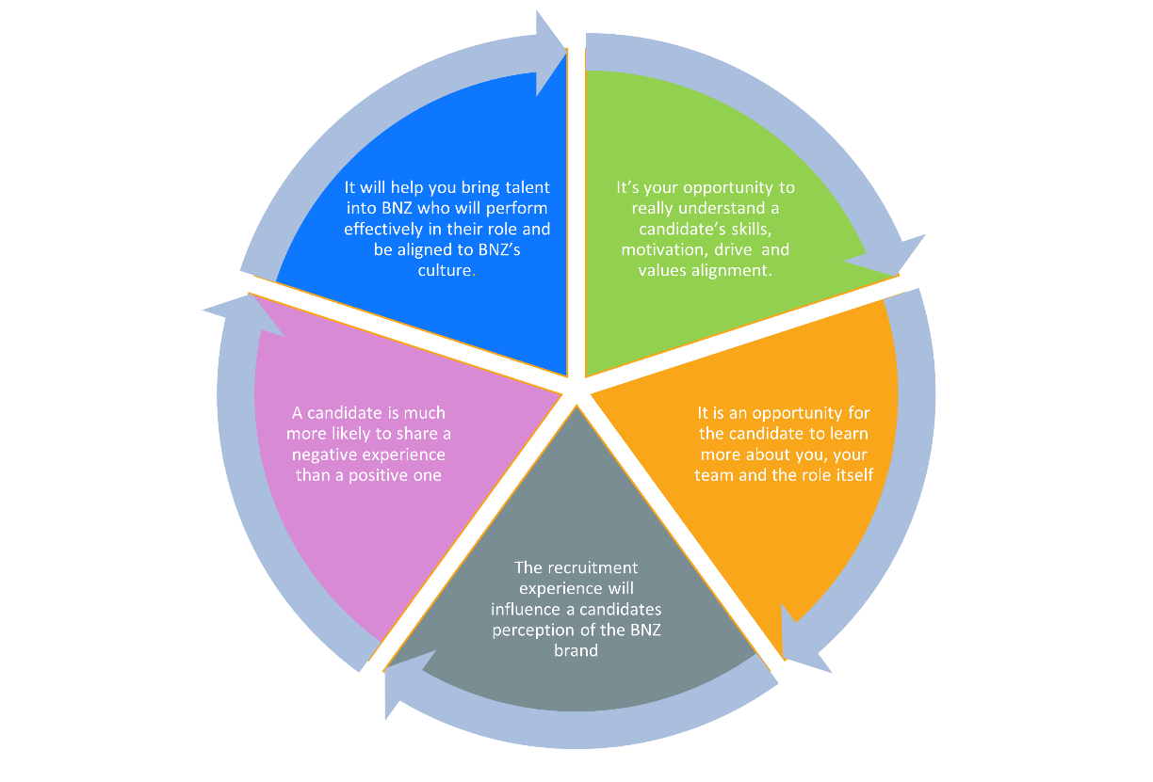
Besides identifying the most qualified candidate, as an interviewer you’re also representing the BNZ brand by demonstrating our Values and Behaviours as you interact with candidates. Making sure that candidates feel comfortable during the interview process is essential as their interview experience will have a direct influence on their perception of BNZ.
Pre-interview checklist
- Review the candidate’s CV and cover letter and think of some specific questions relating to their experience (i.e. technical, industry related, or about the company/team etc).
- Choose one question from each of the ‘values’ questions and create an interview template tailored to the candidate.
- Save the candidates number to your phone in case you need to contact them close to the interview starting.

Tips for holding a great interview
- Build rapport with the candidate by introducing yourself and the other members of the panel in a friendly manner to help to ease any nerves.
- If you’re meeting in the office, offer the candidate a drink and show them where the bathroom is.
- Before you begin, explain how the interview will be structured and the types of questions they’ll be asked (experience, motivation, value based, and closing).
- Outline how the role they have applied for fits into the wider team
- Give them your full attention for the duration of the interview (turn phones off or on silent)
- Take notes to refer back to – bearing in mind that the candidate can request to see these

Position: | Candidate:
Interviewer (s): | Date:

Background questions
These questions will help you understand if the candidate has the experience or potential specific to your role.

Internal & External:

Can you start us off by walking us through your most relevant experience to date?
We’re keen to understand what your responsibilities were, your successes, and your overall journey.
Internal & External:

Can you please tell us what motivated you to apply for this role?

And if you were successful, what skills/experience do you think you could bring?
If Internal and moving from a different area of BNZ, is it part of their IDP YES / NO

External:

What excites you the most about working for BNZ?

Why are you interested in a career within the banking industry?

Internal & External:

What are your mid to long-term careers aspirations?

If you were successful in this role, how would it help you to reach your long-term career goals?
Mātāpono (Who we are) based questions
It’s really important that we employ people whose personal values align with our corporate values, take the candidate through BNZ’s Mātāpono below to help develop their understanding of expected behaviours.
Explain that the next few questions will relate to BNZ’s Mātāpono (Who we are), and we encourage them to think of specific examples to talk through with us, using the Star Technique (Situation, Task, Action, Result).
It’s okay if they don’t have an example from a professional setting, they can answer with an example from their personal life or education instead.

Mātāpono – Who we are | Definition
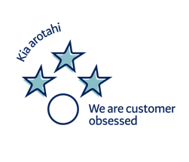 | - We put our customers at the centre of everything we do. Without them, there would be no BNZ.​  - We build enduring customer relationships through empathy and trust.​  - We prioritise exceptional customer service – it’s what sets us apart.​
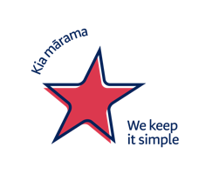 | - We show up for our customers as one team to create consistent, seamless experiences.​  - We make things simple for colleagues so we can be exceptional for our customers.​  - We look for simple solutions when things are complex or don’t make sense.​
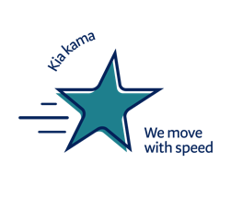 | - We work quickly and with purpose for our customers.​  - We innovate and look for better ways to deliver. If we make mistakes, we learn and correct as we go.​  - We are empowered to make decisions safely for the benefit of our customers.​
 | - We take responsibility for the success of BNZ, beyond our team.​  - We do what is right, even when it’s hard.​  - We never say “that’s not my job”. We take ownership and follow up until it’s resolved.​
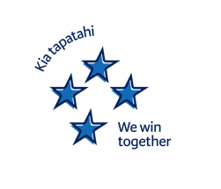 | - We bring the right people together, knowing diverse ideas achieve more.​  - We set bold ambitions and clear expectations to get the best customer outcomes.​  - We speak up on issues and invite challenge working with respect and curiosity.​

We are customer obsessed
Kia arotahi
- We put our customers at the centre of everything we do. Without them, there would be no BNZ.​
- We build enduring customer relationships through empathy and trust.​
- We prioritise exceptional customer service – it’s what sets us apart.

Please pick one question from the below list for each value (keep questions consistent for each role)

1 | Tell us about a time when you exceeded your customers’ expectations? What did you do to achieve this?
2 | Tell us about a time when you were confronted with a challenging internal or external customer? What was the challenge? How did you resolve it?
3 | How you would handle a situation where a customer is asking for something which is not in the interest of BNZ? How would you go about finding a suitable outcome for both the business and customer?
4 | How do you approach building strong relationships with customers, colleagues or stakeholders, where none had previously existed?
5 | Describe a situation where you had to give difficult feedback to someone. How did you ensure you communicated respectfully and constructively?
Situation
Task
Action
Result
Notes:

Rating Scale
1 - Not demonstrated |  | 2 – Partially demonstrated | 3 - Demonstrated | 4 – Strongly demonstrated | 5 – Exceptionally demonstrated
We keep it simple
Kia Mārama
- We show up for our customers as one team to create consistent, seamless experiences.
- We make things simple for colleagues so we can be exceptional for our customers.
- We look for simple solutions when things are complex or don’t make sense.

Please pick one question from the below list for each value (keep questions consistent for each role)

1 | How do you ensure you are providing a consistent level of service to customers (or colleagues)?
2 | Tell us about a recent problem you solved. How did you go about solving it and did you consider any other approaches?
3 | Tell us about a time that you have received feedback for improvement in either your professional or personal life. How did this impact and/or change your approach?
4 | Walk me through your thought process when facing a decision where the “right” choice is not immediately clear.
Situation
Task
Action
Result
Notes:

Rating Scale
1 - Not demonstrated |  | 2 – Partially demonstrated | 3 - Demonstrated | 4 – Strongly demonstrated | 5 – Exceptionally demonstrated
We Own it
Kia mau
- We take responsibility for the success of BNZ, beyond our team.​
- We do what is right, even when it’s hard.​
- We never say “that’s not my job”. We take ownership and follow up until it’s resolved.​

Please pick one question from the below list for each value (keep questions consistent for each role)

1 | Tell us about a challenge you have had to overcome? How did you respond? What was the result? Knowing the outcome, how would you change your actions if this came up again?
2 | What does accountability mean to you, and can you give an example of how you have demonstrated it in a challenging situation?
3 | Describe a time when you had to choose between what was easy and what was right. What factors did you consider?
4 | How do you manage situations where organisational interests might conflict with individual fairness or well-being.
5 | Tell us about a time something significant didn’t go according to plan at work. What was your role? What was the outcome?
6 | Tell us about a situation when your individual ethics have been challenged? Why did it not align with your values? What was it and what did you do about it?
Situation
Task
Action
Result
Notes:

Rating Scale
1 - Not demonstrated |  | 2 – Partially demonstrated | 3 - Demonstrated | 4 – Strongly demonstrated | 5 – Exceptionally demonstrated
We win together
Kia tapatahi
- We bring the right people together, knowing diverse ideas achieve more.​
- We set bold ambitions and clear expectations to get the best customer outcomes.​
- We speak up on issues and invite challenge working with respect and curiosity.​

Please pick one question from the below list for each value (keep questions consistent for each role)

1 | Can you please tell us about a time that you had to influence someone or a group to achieve the right outcome? What was the situation and the outcome?
2 | What has been your biggest career achievement to date? What made it so memorable?
3 | Tell me about a time when you helped create a more inclusive environment for your team or organisation.
4 | How do you ensure everyone’s voice is hear in group settings or team discussions?
5 | Tell us about a time when you challenged a decision or process. Did you manage to convince your colleagues / stakeholders to do things differently? What was your approach?
6 | Tell me about a time you have had to work with someone whose background, perspective or working style was quite different from yours. How did you navigate that relationship?
Situation
Task
Action
Result
Notes:
Rating Scale
1 - Not demonstrated |  | 2 – Partially demonstrated | 3 - Demonstrated | 4 – Strongly demonstrated | 5 – Exceptionally demonstrated

We move with speed
Kia Kama
- We work quickly and with purpose for our customers.​
- We innovate and look for better ways to deliver. If we make mistakes, we learn and correct as we go.​
- We are empowered to make decisions safely for the benefit of our customers.​

Please pick one question from the below list for each value (keep questions consistent for each role)

1 | Tell us about a time that you have had to manage several conflicting priorities. How have you made sure to deliver on these?
2 | Can you please provide an example of a time when you delegated an important task successfully.
3 | Can you please talk us through a time you made a mistake? What did you do? What was the end result?
4 | Tell us about a time where you were under time pressure and needed to make a decision. How did you approach this and what was the result?
Situation
Task
Action
Result
Notes:

Rating Scale
1 - Not demonstrated |  | 2 – Partially demonstrated | 3 - Demonstrated | 4 – Strongly demonstrated | 5 – Exceptionally demonstrated
Fair conduct and ethics questions:
Please pick one question from the below list for each value (keep questions consistent for each role)

1 | Describe a time when you have witnessed unfair treatment of a colleague or customer. How did you manage the situation, and what would you do differently if faced with a similar scenario today?
2 | If you noticed a process or policy that appears to disadvantage certain groups/segments of the customer base, what steps would you take?
3 | Describe a time when you had to choose between what was best for the organisation’s short-term profits and what was fair for the customer. How did you manage it?
4 | Walk me through a time when you had to deliver disappointing news to a customer. How did you ensure you were honest and transparent while maintaining the relationship?
5 | Describe a situation where you discovered an error that negatively affected a customer. How did you handle making it right?
Situation
Task
Action
Result
Notes:

Rating Scale
1 - Not demonstrated |  | 2 – Partially demonstrated | 3 - Demonstrated | 4 – Strongly demonstrated | 5 – Exceptionally demonstrated

Closing questions

In terms of Leadership, what are the two most important qualities you’re looking for in your people leader?

Internal BNZ employees:
What are your salary expectations for this role?
Are you in the process for any other roles, that we need to be aware of?
Is your people leader aware that you have applied/interviewed for this role?
If we decide to progress, we’ll need to speak with your People Leader – are you okay with this?
Do you have any upcoming leave over the next six months that we should be aware of?
External candidates:
What is your current / most recent salary?
Ask if including bonus / car etc
What are your salary expectations for this role?
Ask if including bonus / car etc
Are you in the process for any other roles at the moment that we need to be aware of?
What is your notice period/ availability
to begin new employment?
Do you have any upcoming leave over the next six months that we should be aware of?

Employment type – confirm they’re aware the role is either permanent, fixed term / secondment, or casual.
Flexible working – please talk through the working from home policy currently in your team.
Thank the candidate for their time and explain the next steps / timeframes to hear back from you.

